Triangle–Circular Open Shapes
# Source: AI Source: Provided by: [Data Path: Persons Table -> ID Column: 1, Name_En Column: Motasem Essam] -> From: [ChatGPT] on [7/25/2026]
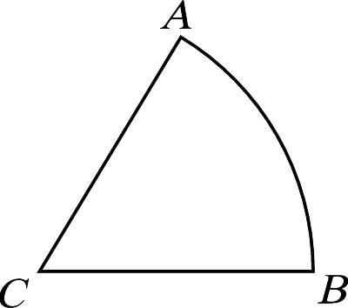
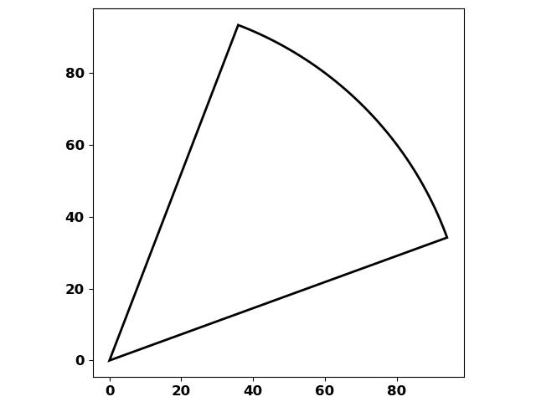
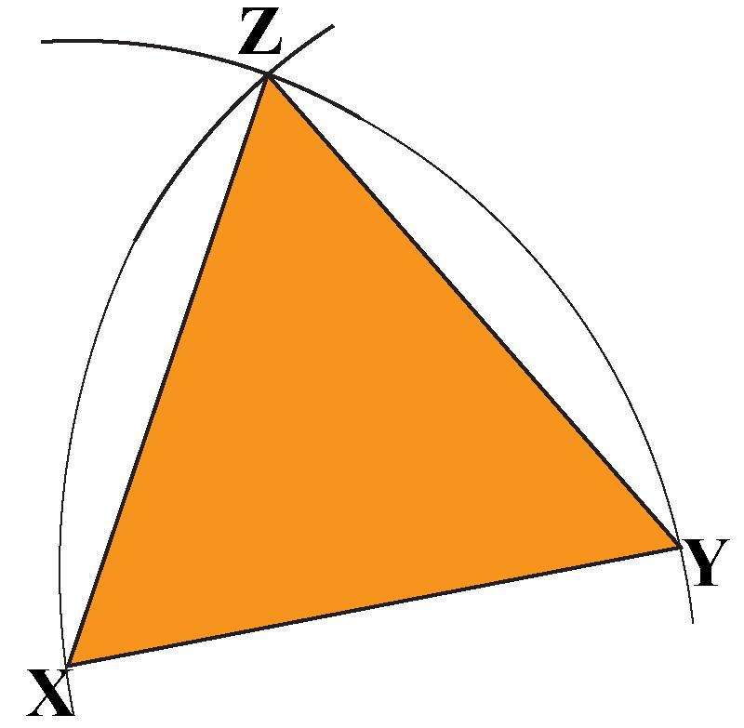
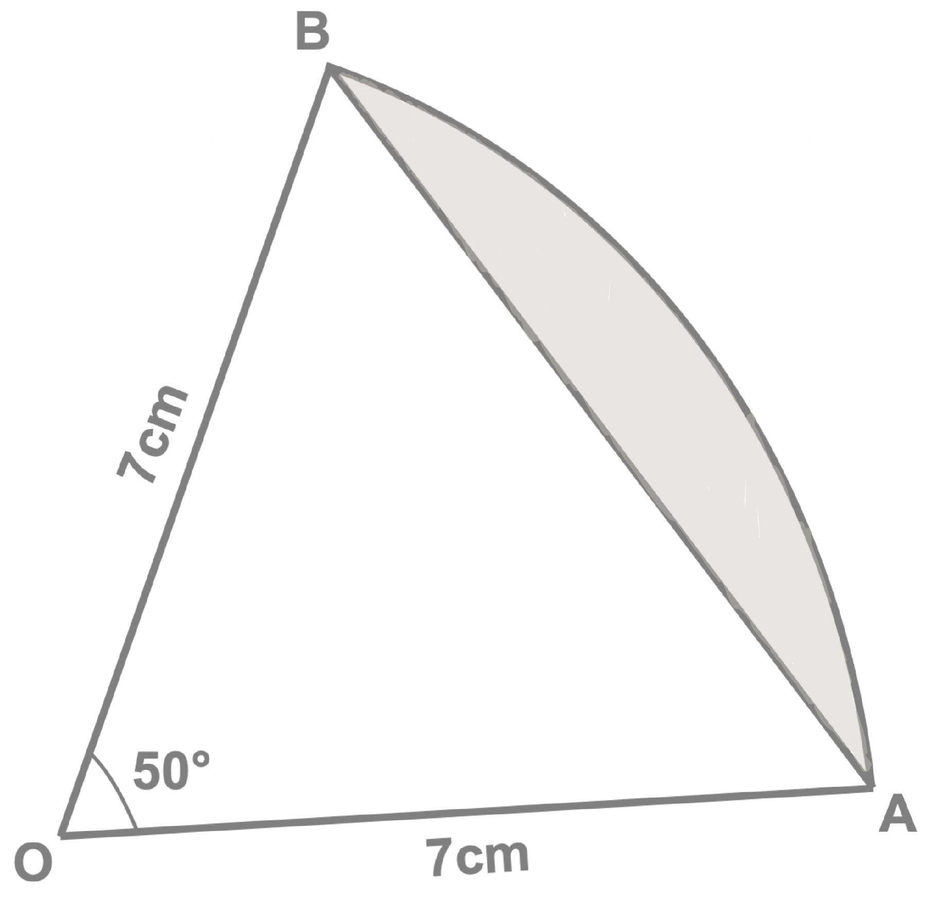

Definition
# Source: AI Source: Provided by: [Data Path: Persons Table -> ID Column: 1, Name_En Column: Motasem Essam] -> From: [ChatGPT] on [7/25/2026]
A Triangle–Circular Open Shape is an open mixed shape that combines straight triangular segments with one or more circular arcs.
$$\boxed{\text{Triangle–Circular Open Shape}=\text{Triangular Segments}+\text{Circular Arc(s)}+\text{Open Boundary}}$$
The shape remains open because its boundary does not completely connect to form a closed region.

Characteristics
# Source: AI Source: Provided by: [Data Path: Persons Table -> ID Column: 1, Name_En Column: Motasem Essam] -> From: [ChatGPT] on [7/25/2026]
A Triangle–Circular Open Shape:
- Is open.
- Contains straight segments associated with a triangle.
- Contains at least one circular arc.
- Combines triangular and circular geometry.
- Has two or more endpoints.
- May contain sharp corners.
- May contain smooth tangent connections.
- Does not enclose an area by itself.
- Can be symmetric or asymmetric.
- Can be regular-looking or irregular.

Types of Triangle–Circular Open Shapes

1. Single-Arc Triangle Open Shape
# Source: AI Source: Provided by: [Data Path: Persons Table -> ID Column: 1, Name_En Column: Motasem Essam] -> From: [ChatGPT] on [7/25/2026]
A triangular open path containing one circular arc.
This is one of the simplest triangle–circular combinations.

2. Multi-Arc Triangle Open Shape
# Source: AI Source: Provided by: [Data Path: Persons Table -> ID Column: 1, Name_En Column: Motasem Essam] -> From: [ChatGPT] on [7/25/2026]
A triangular arrangement containing multiple circular arcs separated by straight segments.
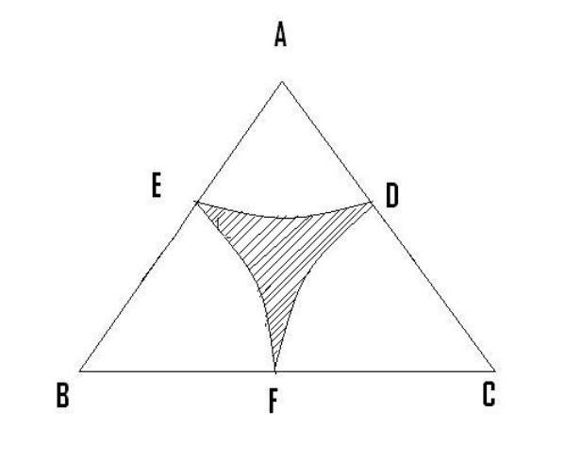
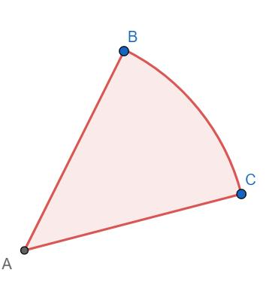
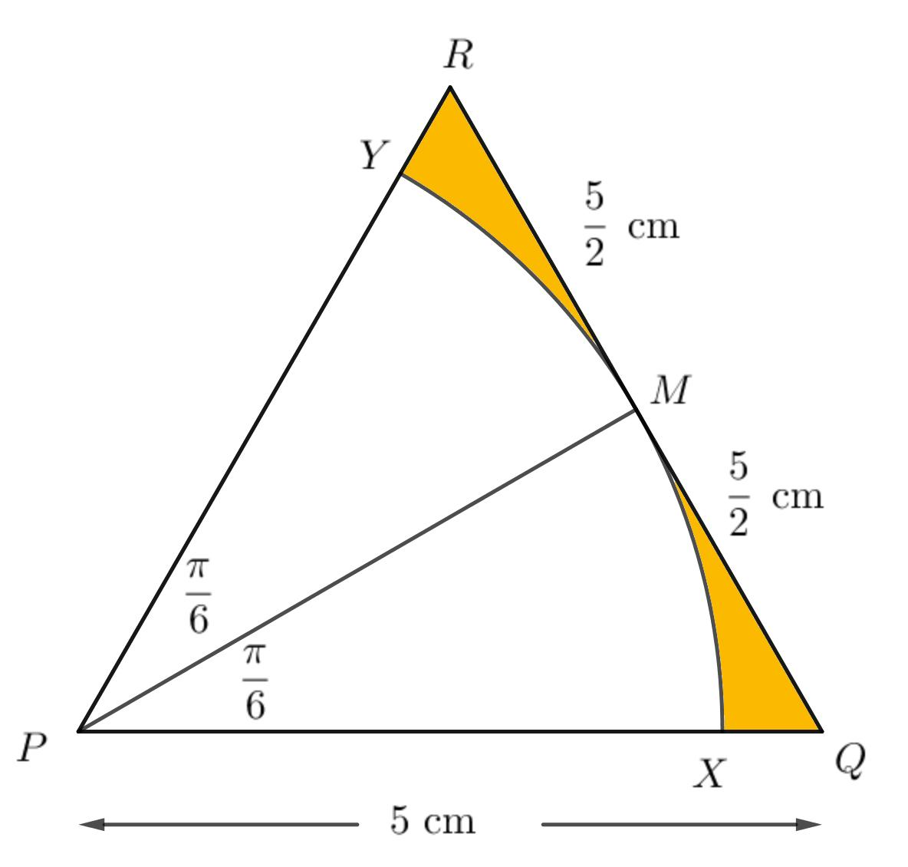
The arcs may have equal or different radii.

3. Rounded-Corner Triangle Open Shape
# Source: AI Source: Provided by: [Data Path: Persons Table -> ID Column: 1, Name_En Column: Motasem Essam] -> From: [ChatGPT] on [7/25/2026]
One or more triangular corners are replaced or softened by circular arcs.
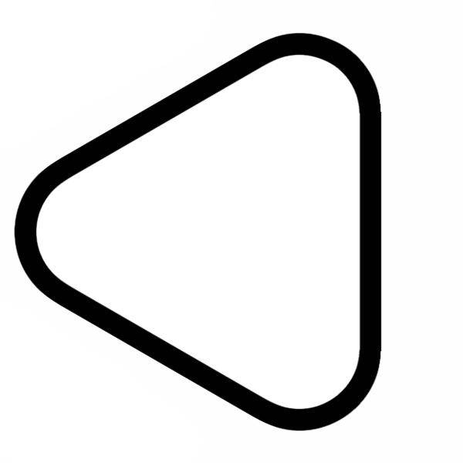
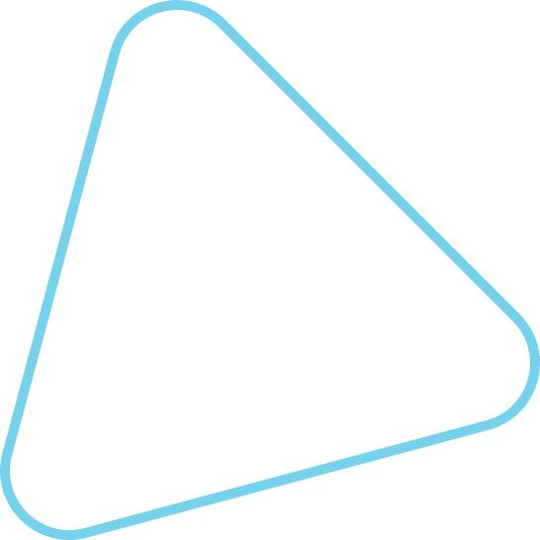
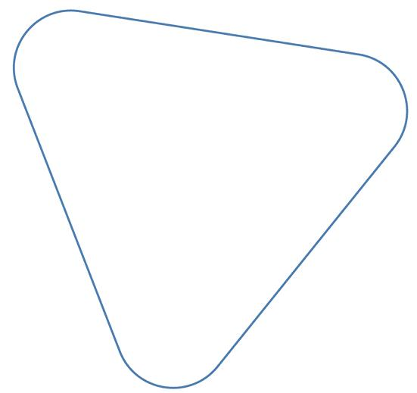
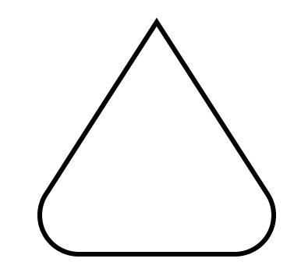
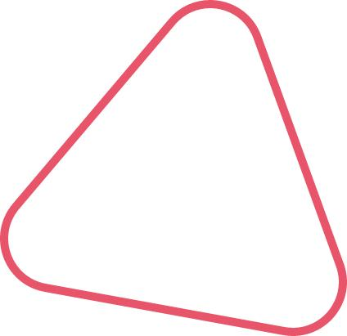
The curved sections replace sharp triangular corners.

4. Semicircular-Ended Triangle Open Shape
# Source: AI Source: Provided by: [Data Path: Persons Table -> ID Column: 1, Name_En Column: Motasem Essam] -> From: [ChatGPT] on [7/25/2026]
A triangular open path has a semicircular or approximately semicircular section at one end.
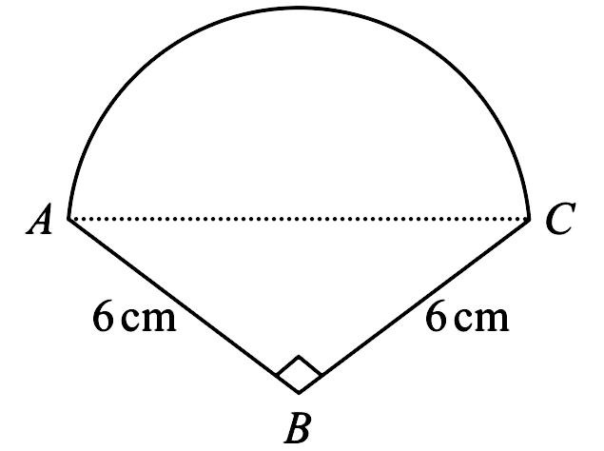
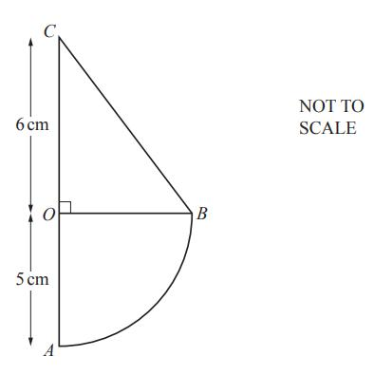
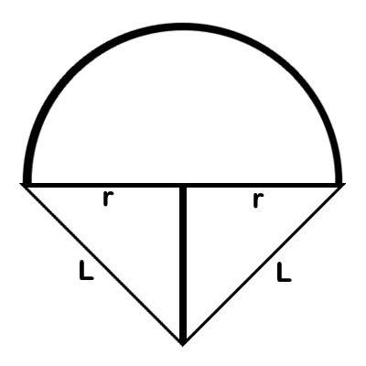
This combines straight triangular sections with a larger circular arc.

5. Tangential Triangle–Circular Open Shape
# Source: AI Source: Provided by: [Data Path: Persons Table -> ID Column: 1, Name_En Column: Motasem Essam] -> From: [ChatGPT] on [7/25/2026]
A straight triangular segment connects smoothly to a circular arc at a tangent point.
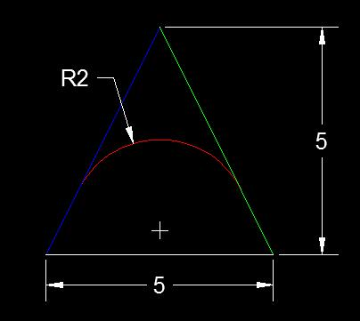
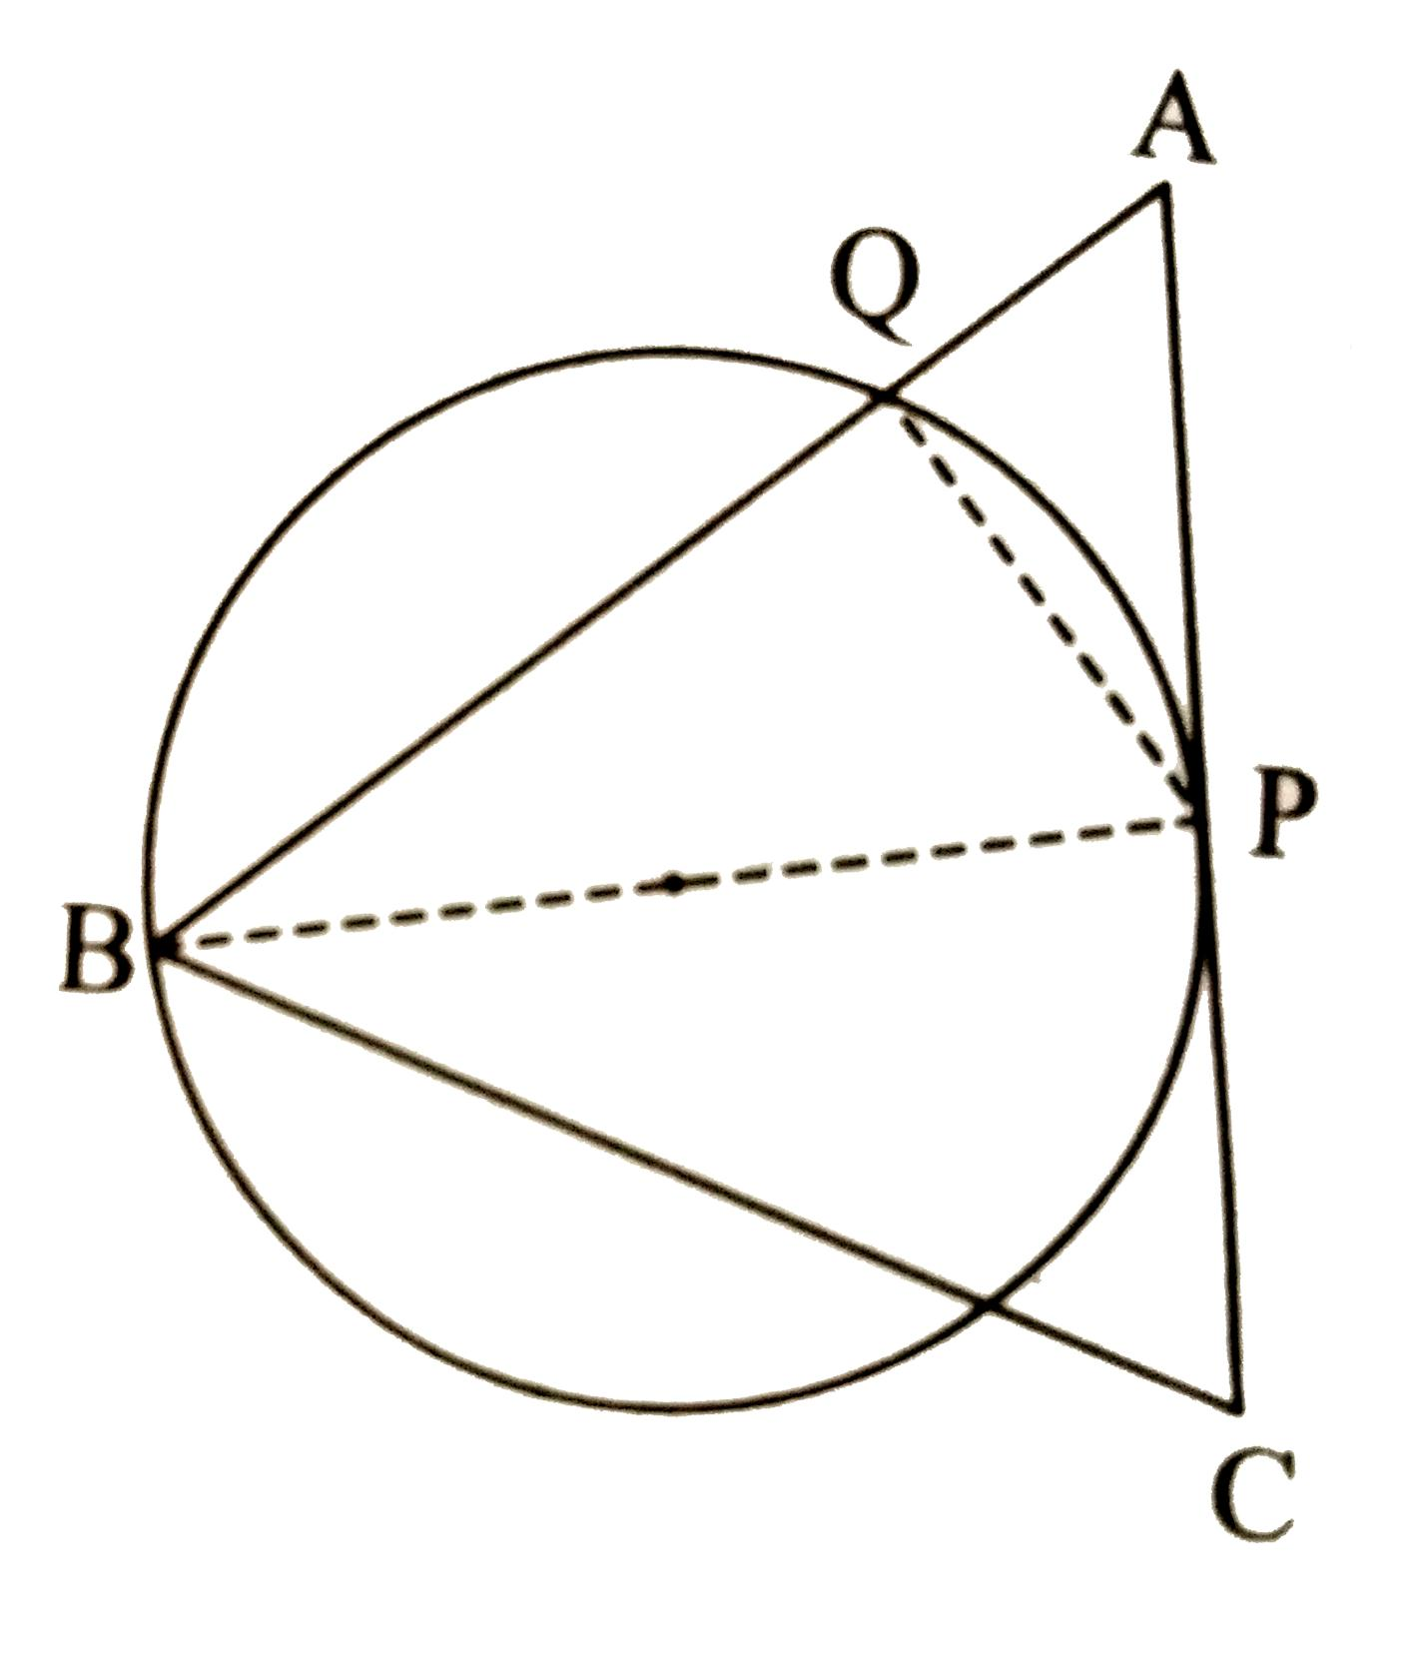
The straight segment and arc can share the same tangent direction at the joining point.

6. Cornered Triangle–Circular Open Shape
# Source: AI Source: Provided by: [Data Path: Persons Table -> ID Column: 1, Name_En Column: Motasem Essam] -> From: [ChatGPT] on [7/25/2026]
A circular arc meets a triangular segment at a visible corner.
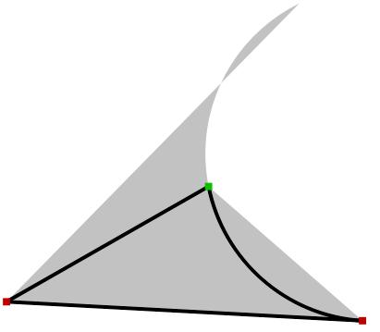
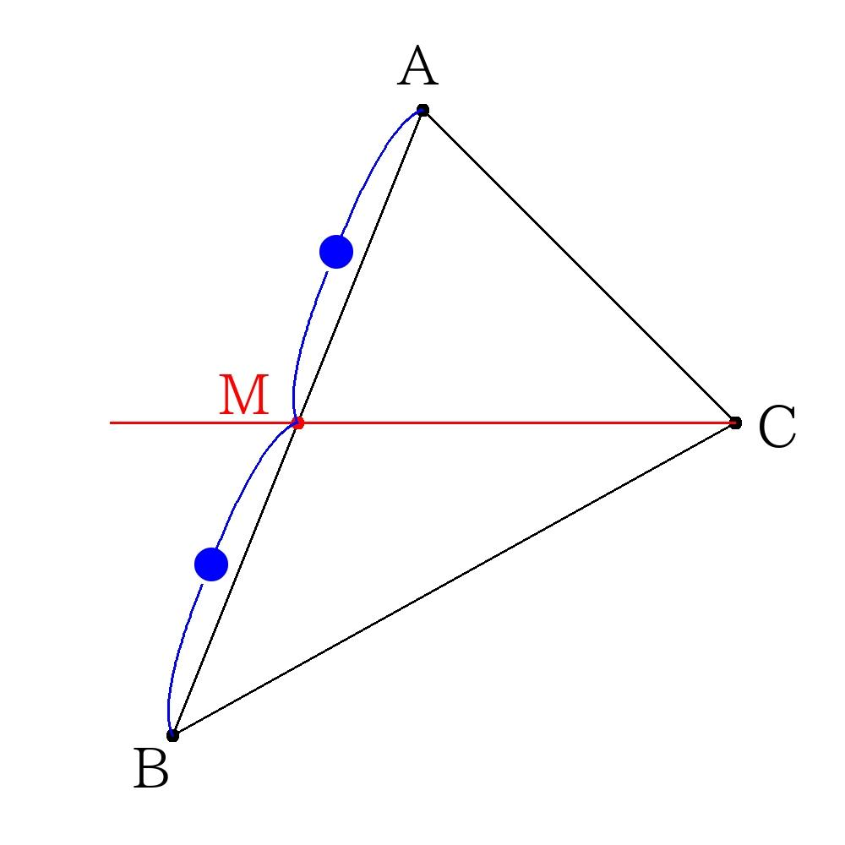
Unlike a tangential connection, the direction changes abruptly at the junction.

7. Symmetric Triangle–Circular Open Shape
# Source: AI Source: Provided by: [Data Path: Persons Table -> ID Column: 1, Name_En Column: Motasem Essam] -> From: [ChatGPT] on [7/25/2026]
The triangular segments and circular arcs are arranged with recognizable symmetry.
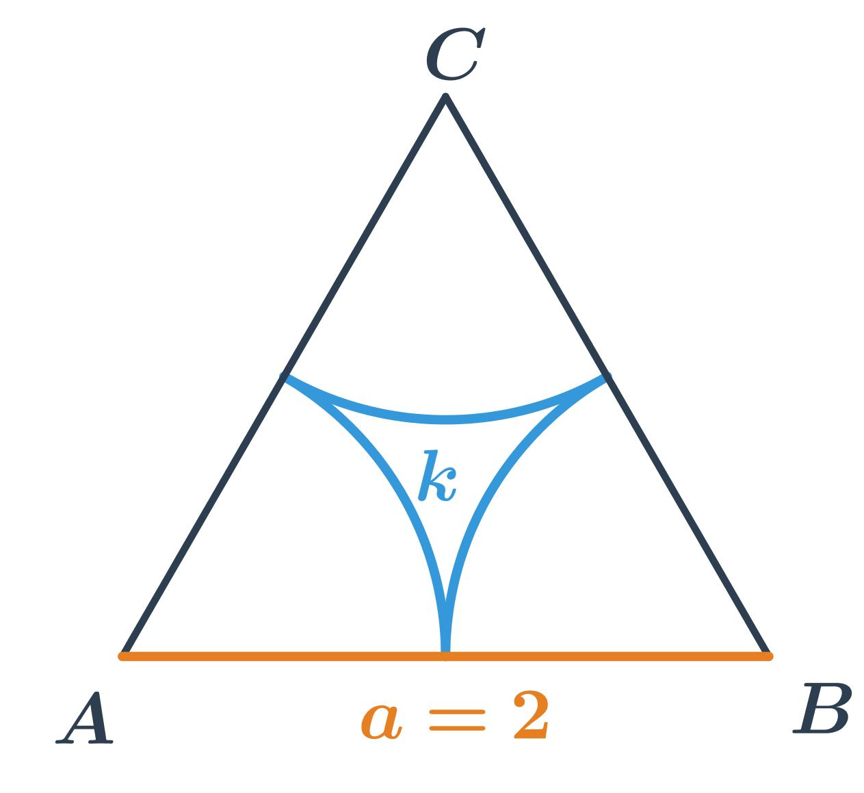
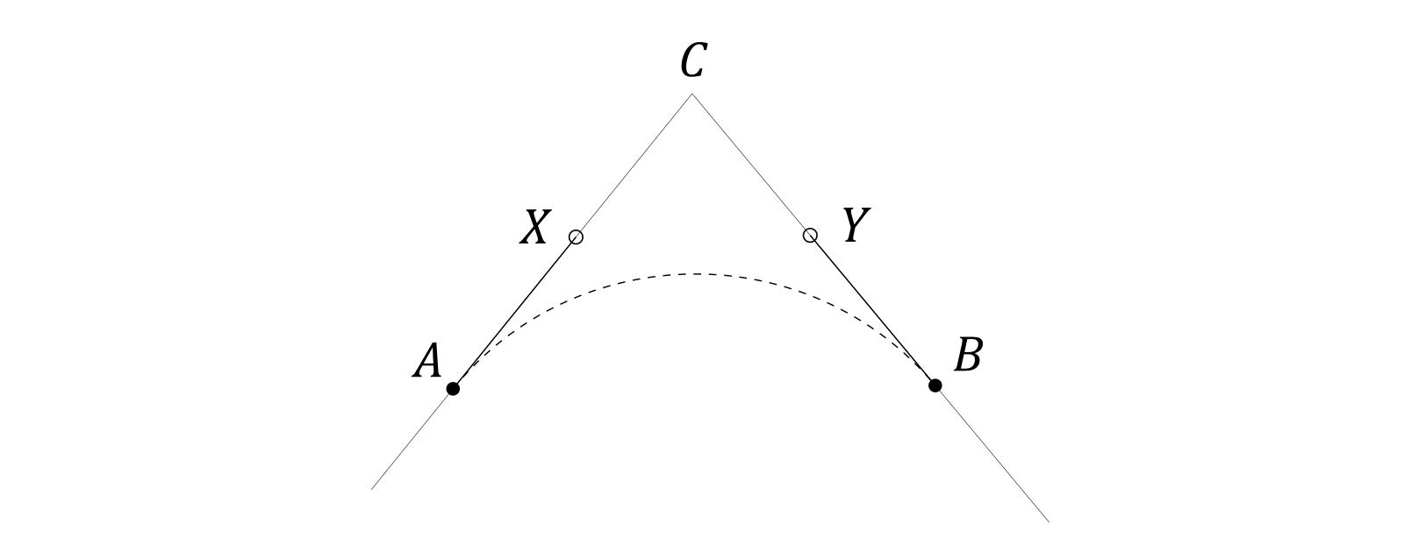
The symmetry may be vertical, horizontal, or another recognizable reflection.

8. Asymmetric Triangle–Circular Open Shape
# Source: AI Source: Provided by: [Data Path: Persons Table -> ID Column: 1, Name_En Column: Motasem Essam] -> From: [ChatGPT] on [7/25/2026]
The triangular segments and circular arcs have unequal positions, lengths, or radii.
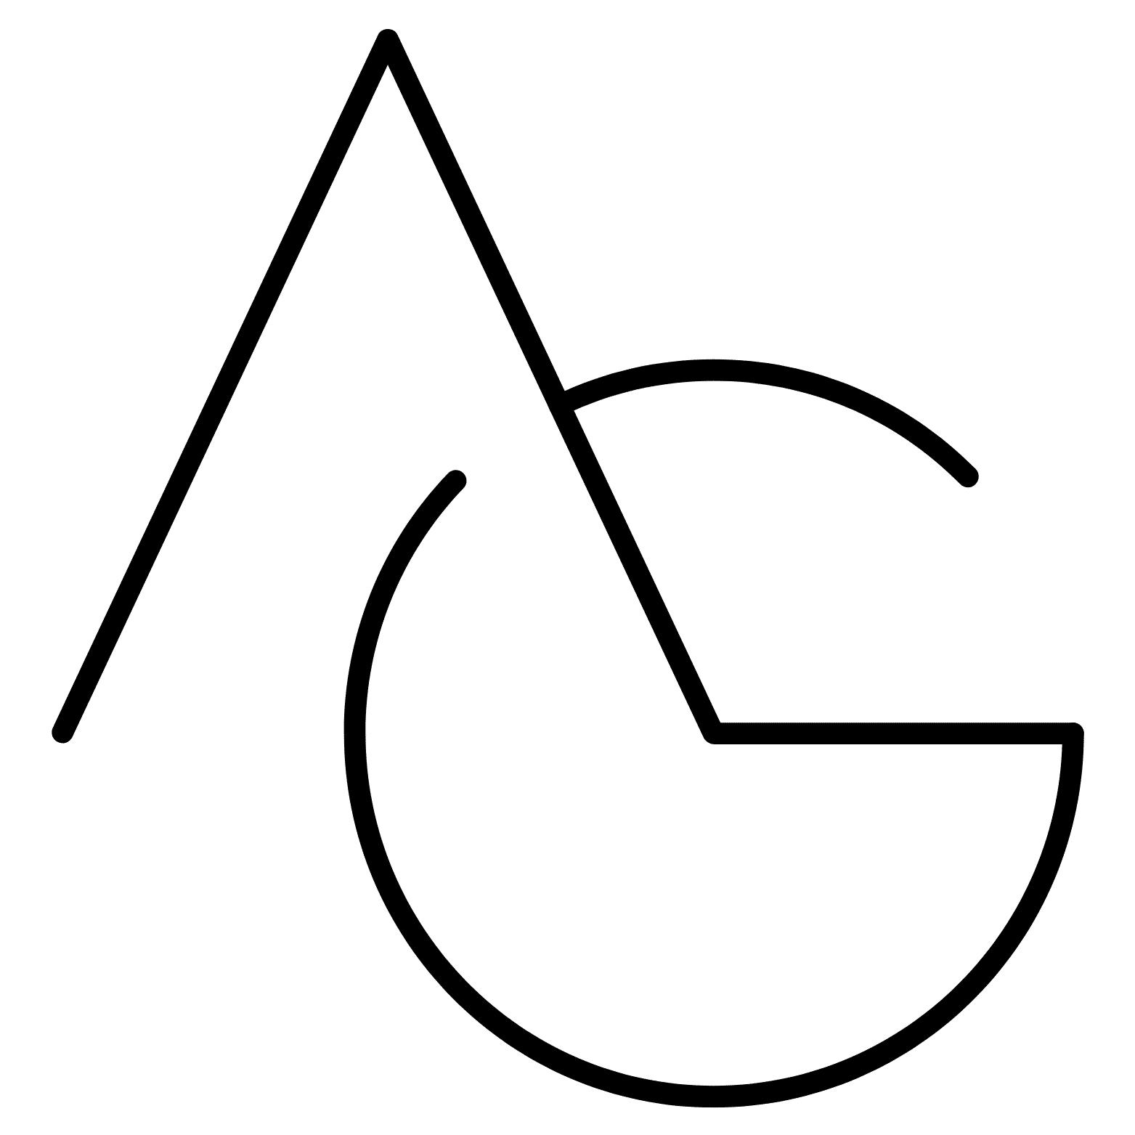
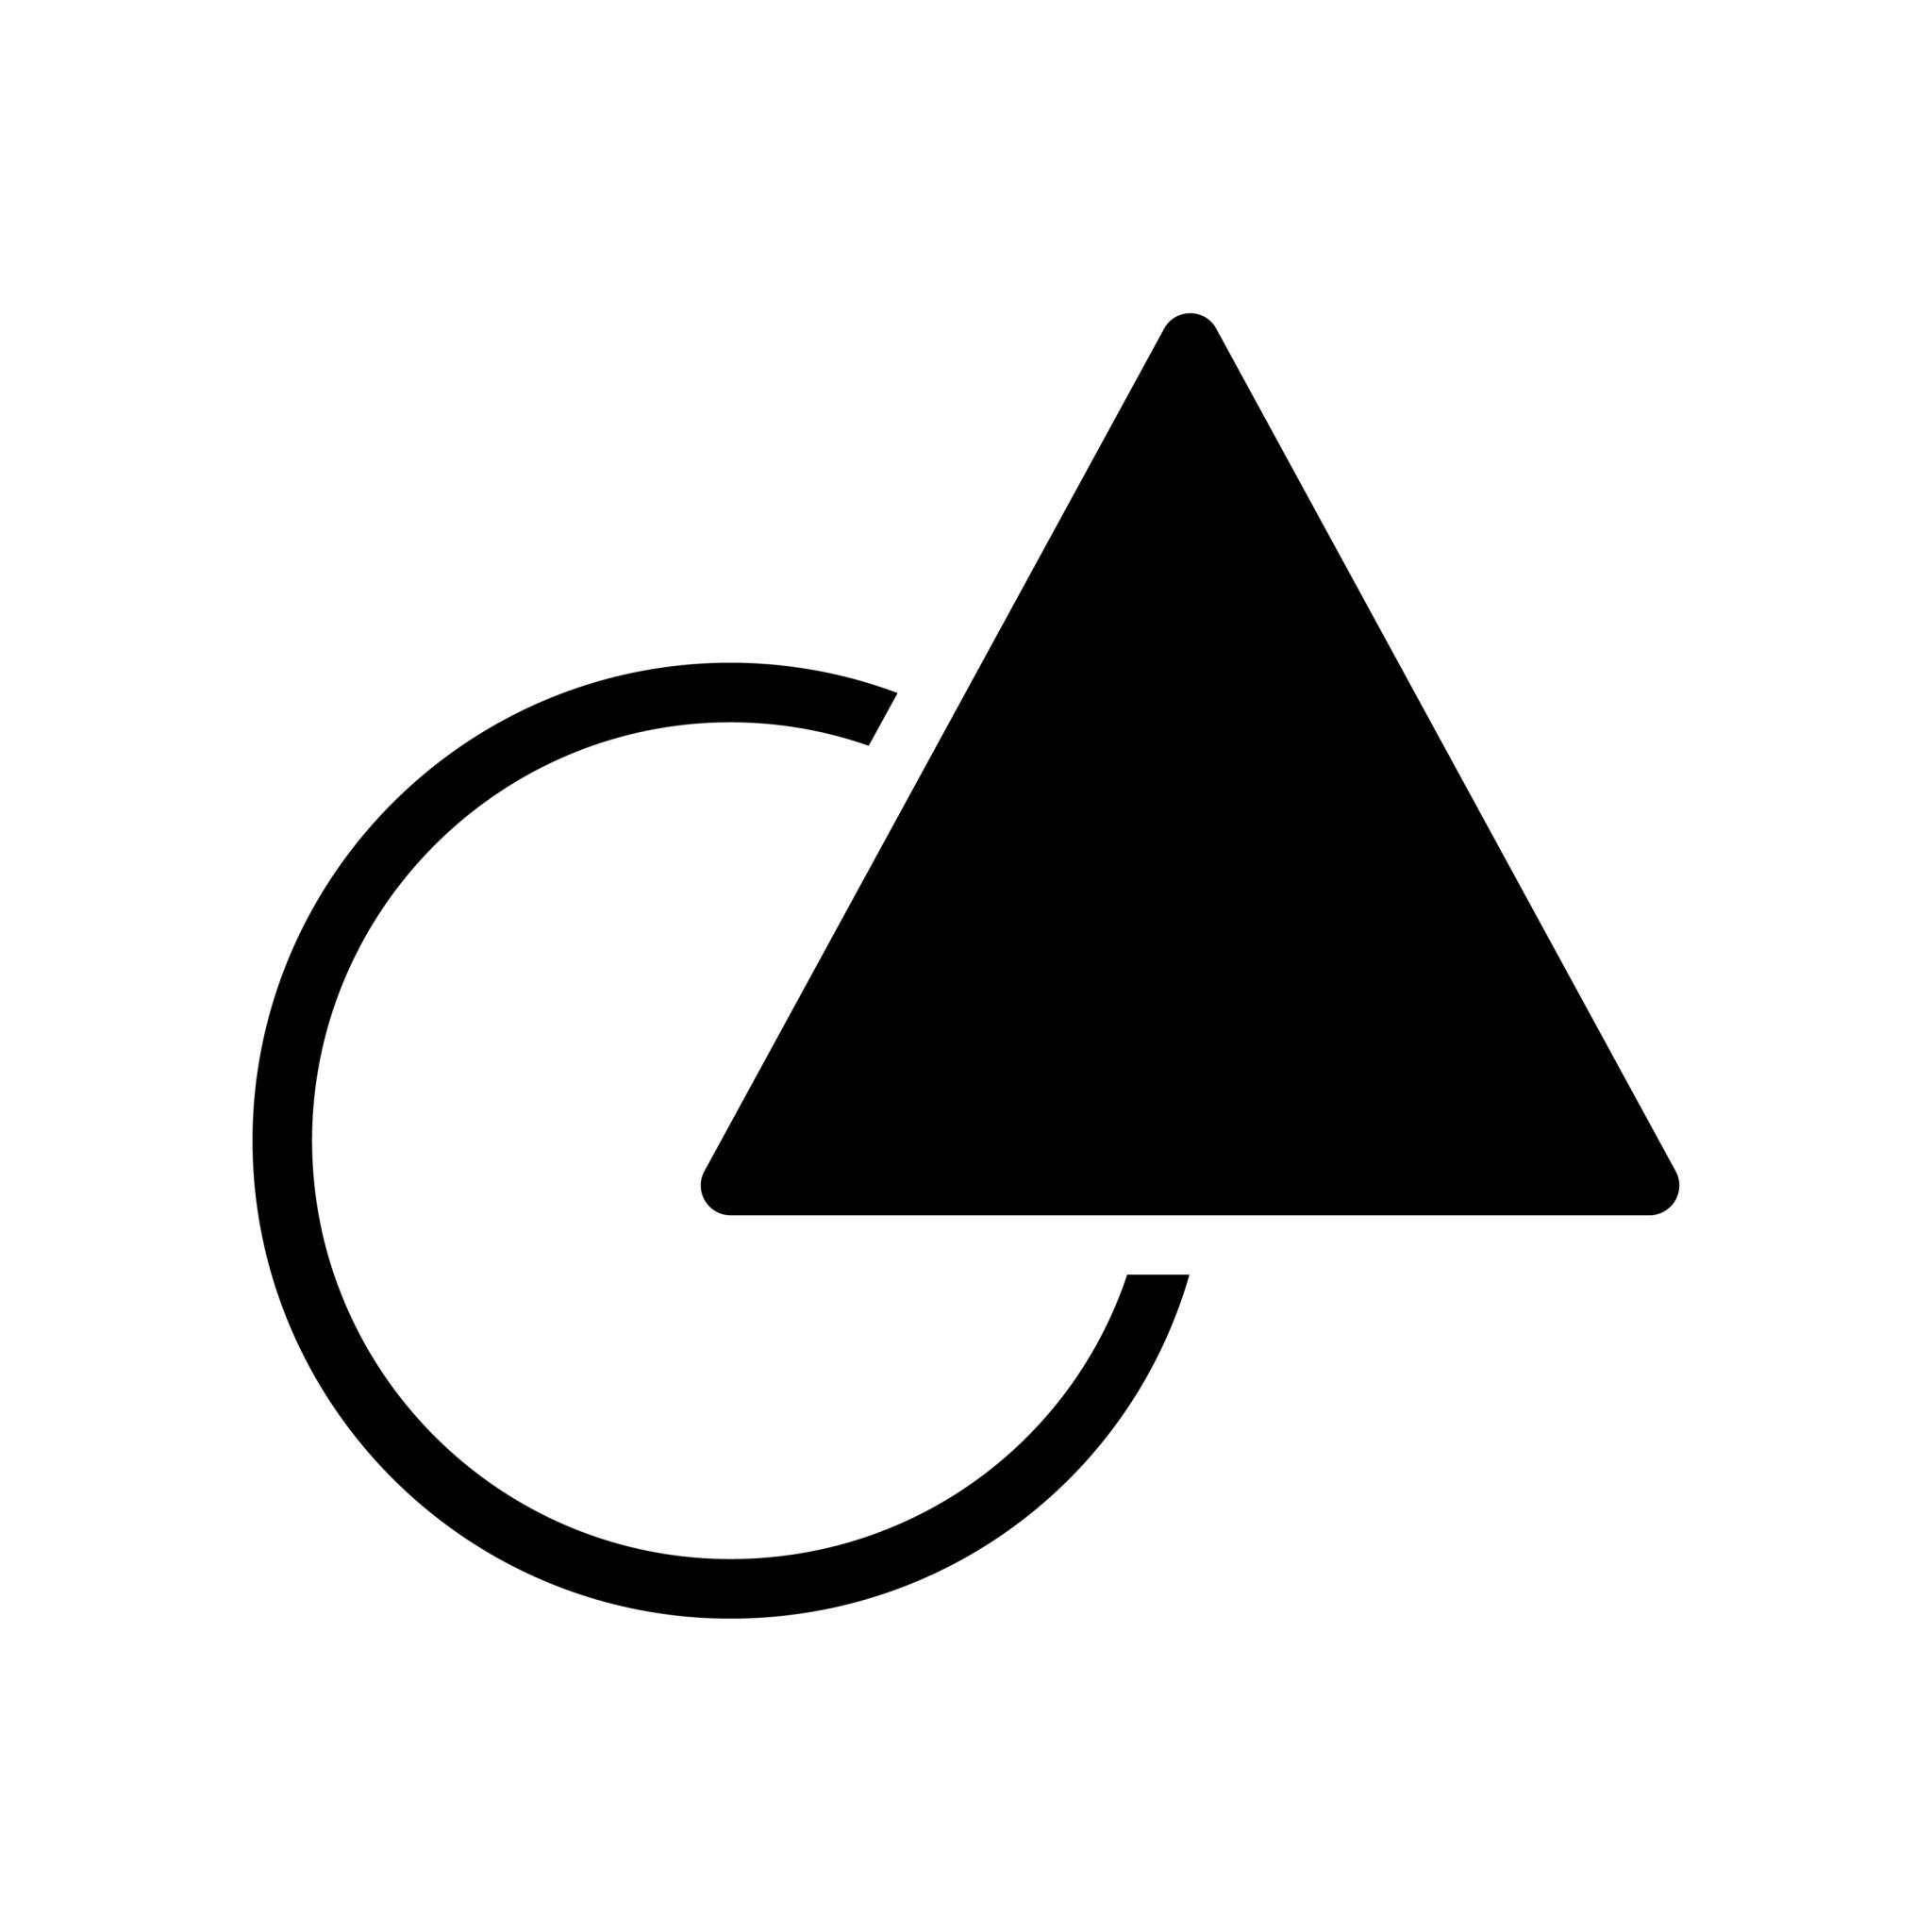

This is useful for classifying irregular mixed shapes.

9. Wavy Triangle–Circular Open Shape
# Source: AI Source: Provided by: [Data Path: Persons Table -> ID Column: 1, Name_En Column: Motasem Essam] -> From: [ChatGPT] on [7/25/2026]
Triangular straight segments and circular arcs are arranged into a wave-like open path.
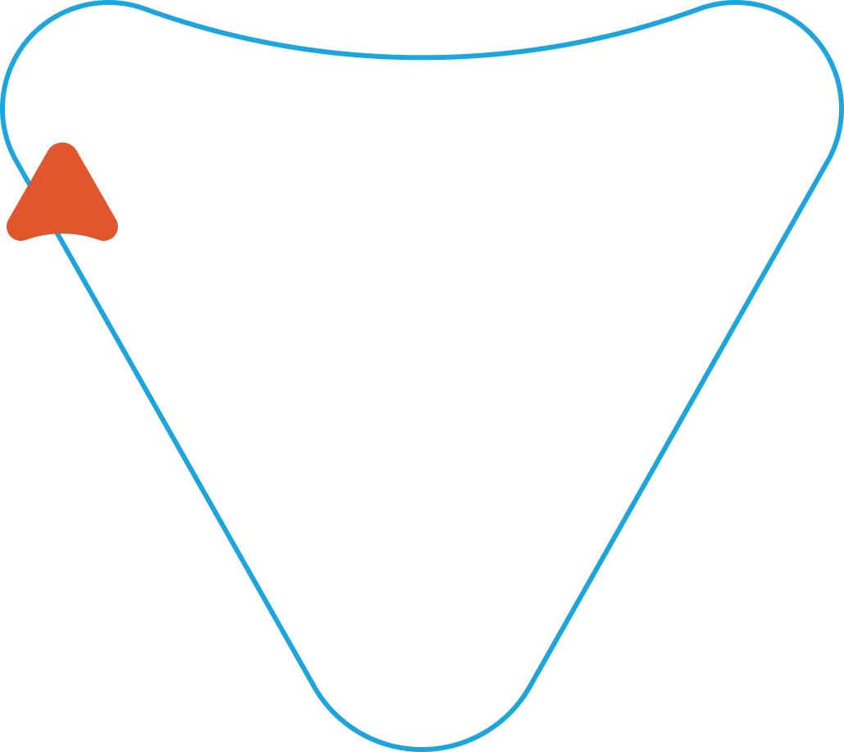
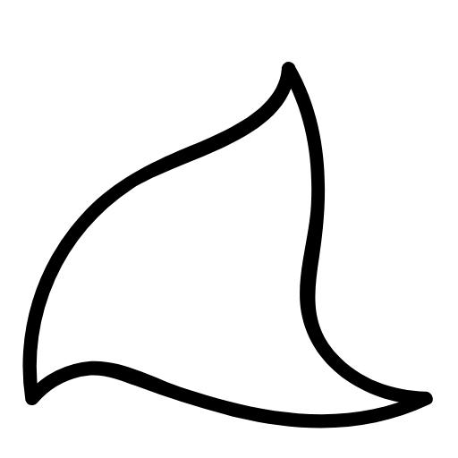
The overall path alternates between straight and curved portions.

10. Step-Like Triangle–Circular Open Shape
# Source: AI Source: Provided by: [Data Path: Persons Table -> ID Column: 1, Name_En Column: Motasem Essam] -> From: [ChatGPT] on [7/25/2026]
Straight segments form a stepped arrangement while circular arcs are incorporated into some sections.
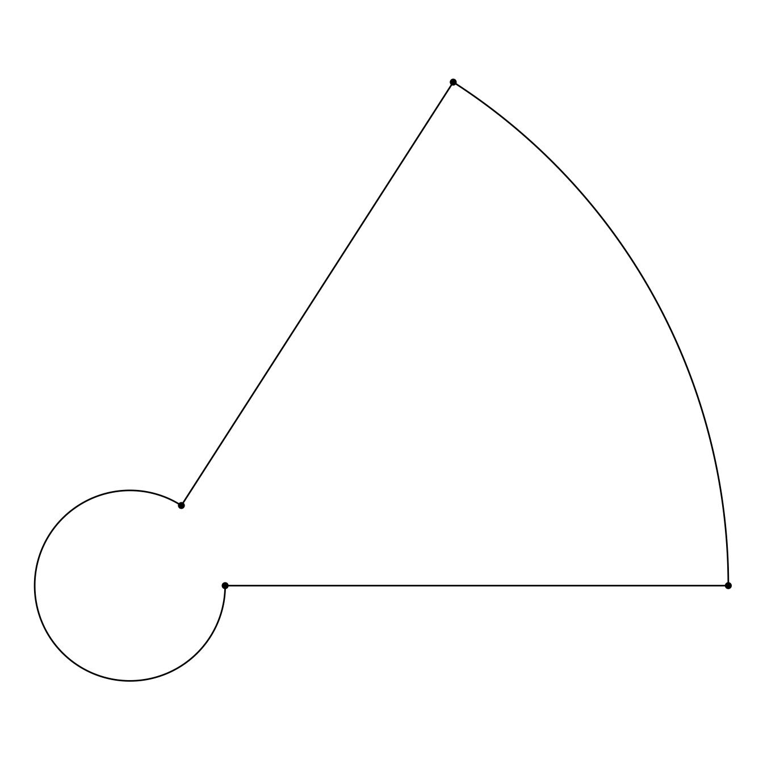
This can be useful when the triangular component is irregular rather than a simple triangle.

11. Freeform Triangle–Circular Open Shape
# Source: AI Source: Provided by: [Data Path: Persons Table -> ID Column: 1, Name_En Column: Motasem Essam] -> From: [ChatGPT] on [7/25/2026]
A freely designed open path combining triangular segments and circular arcs.
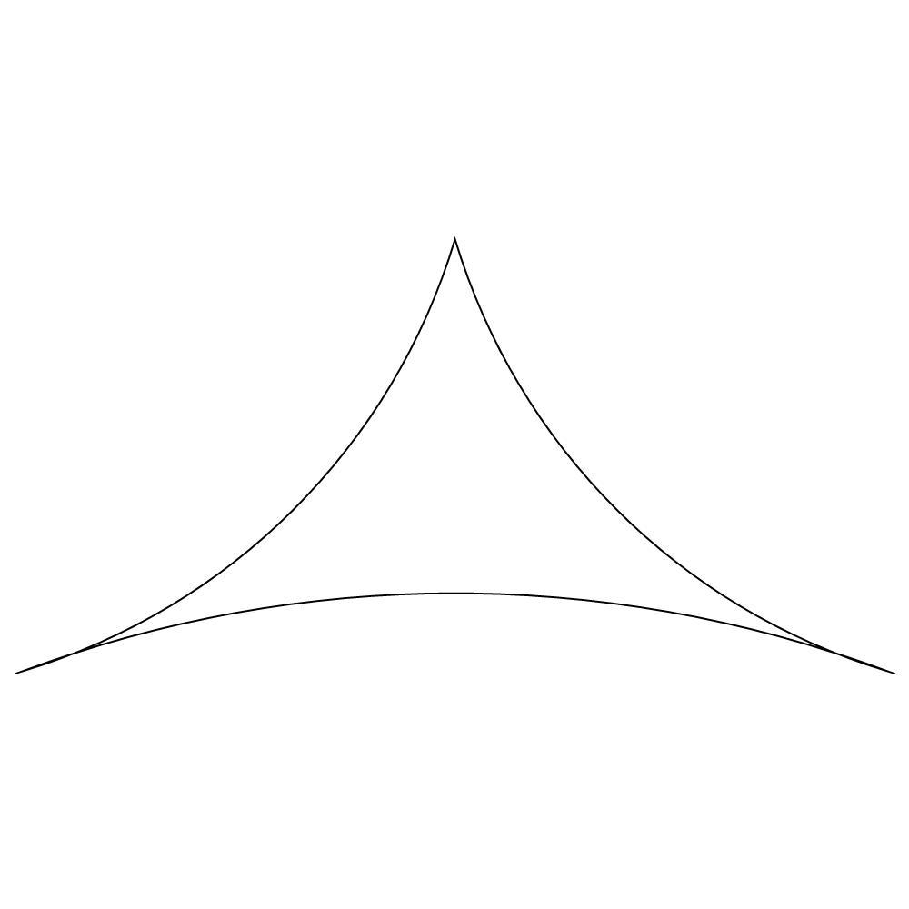
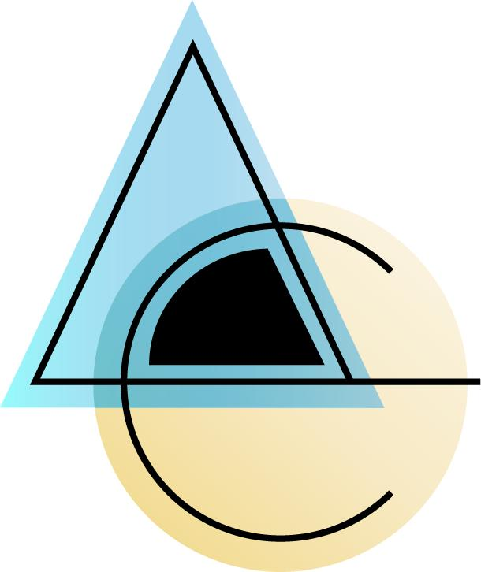
It does not follow one fixed standard configuration.

12. Irregular Triangle–Circular Open Shape
# Source: AI Source: Provided by: [Data Path: Persons Table -> ID Column: 1, Name_En Column: Motasem Essam] -> From: [ChatGPT] on [7/25/2026]
An irregular combination of triangular segments and circular arcs with varying lengths, angles, or radii.
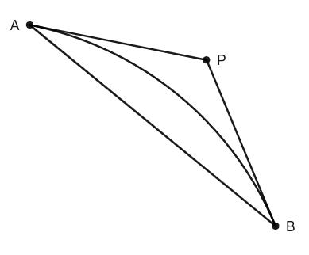
The overall form has no regular repeating structure.

Triangle–Circular vs. Polygon–Circular Open Shapes
# Source: AI Source: Provided by: [Data Path: Persons Table -> ID Column: 1, Name_En Column: Motasem Essam] -> From: [ChatGPT] on [7/25/2026]
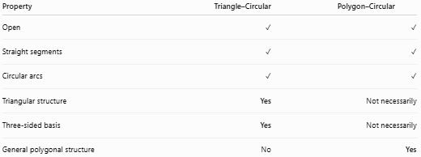
Property | Triangle–Circular | Polygon–Circular
Open | ✓ | ✓
Straight segments | ✓ | ✓
Circular arcs | ✓ | ✓
Triangular structure | Yes | Not necessarily
Three-sided basis | Yes | Not necessarily
General polygonal structure | No | Yes
Main distinction
$$\boxed{\text{Triangle–Circular}=\text{Triangular Segments + Circular Arcs}}$$
while:
$$\boxed{\text{Polygon–Circular}=\text{General Polygonal Segments + Circular Arcs}}$$

Triangle–Circular vs. Rectangle–Circular Open Shapes
# Source: AI Source: Provided by: [Data Path: Persons Table -> ID Column: 1, Name_En Column: Motasem Essam] -> From: [ChatGPT] on [7/25/2026]
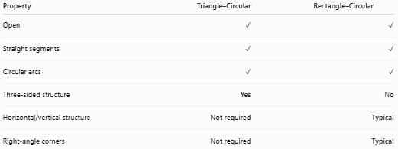
Property | Triangle–Circular | Rectangle–Circular
Open | ✓ | ✓
Straight segments | ✓ | ✓
Circular arcs | ✓ | ✓
Three-sided structure | Yes | No
Horizontal/vertical structure | Not required | Typical
Right-angle corners | Not required | Typical

Key Points
# Source: AI Source: Provided by: [Data Path: Persons Table -> ID Column: 1, Name_En Column: Motasem Essam] -> From: [ChatGPT] on [7/25/2026]
A Triangle–Circular Open Shape is:
$$\boxed{\text{Open}+\text{Triangular}+\text{Circular}}$$
It:
- Contains straight triangular segments.
- Contains at least one circular arc.
- Is not completely closed.
- Has two or more endpoints.
- May have sharp corners or smooth tangent connections.
- May contain one or multiple arcs.
- Can be symmetric or asymmetric.
- Can be regular-looking, irregular, wavy, step-like, or freeform.

Conclusion
# Source: AI Source: Provided by: [Data Path: Persons Table -> ID Column: 1, Name_En Column: Motasem Essam] -> From: [ChatGPT] on [7/25/2026]
Triangle–Circular Open Shapes are mixed open shapes that combine the straight-sided structure associated with triangles and the curved geometry of circular arcs. Their defining feature is the combination of triangular and circular components while remaining open.

